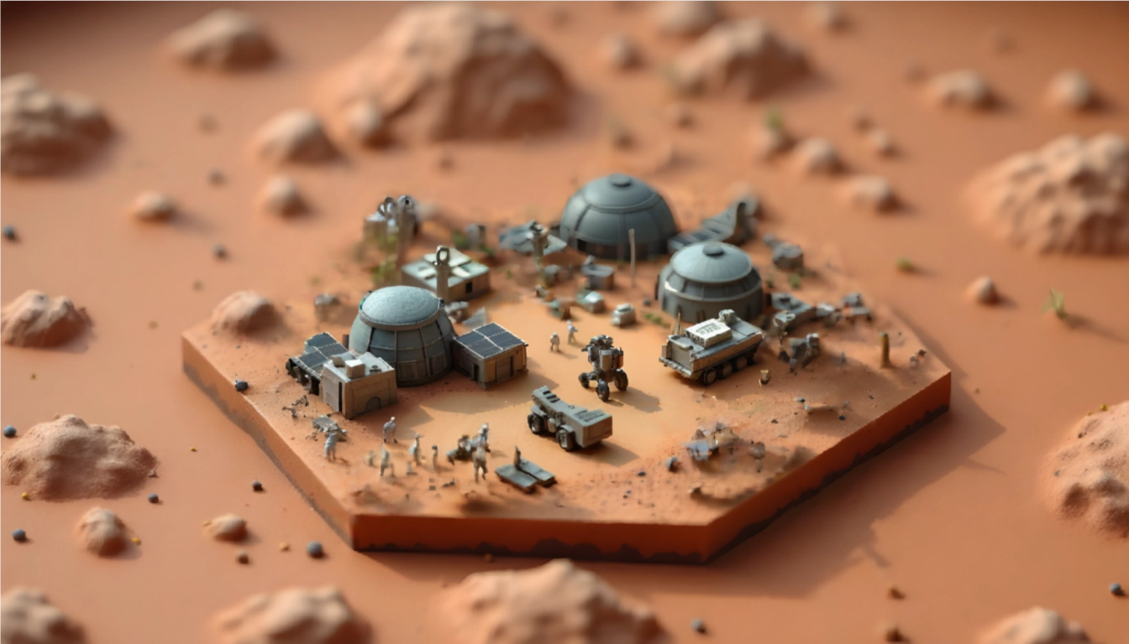  Mission Mars  A Colony | Abstract  The Interplanetary Development Corporations IDC is requesting proposals for the establishment of a colony on the surface of Mars. The proposed timeline for the successful bid will the completion of the facility by 2065.  User  The Interplanetary Development Corporation

IDC 2050: MISSION MARS - REQUEST FOR PROPOSALS v2.0
Introduction
The Interplanetary Development Corporation has requested proposals for the development and operation of a colony on Mars. This will be the first human outpost on the Martian surface designed to support a contingent of up to 500 permanent residents after completion. The facility must also have capacity for up to 150 transient individuals involved in operational capacities such as transport crew, visiting scientists and engineers, administrative and security personnel, and tourists.
Total design load: 650 people
Statement of Work
The facility must provide a safe and pleasant work and leisure environment for all inhabitants and visitors. It must also be able to derive sustainable independent operations without the immediate necessity of support from Earth-based resources.
This must include:
- The construction of habitats beyond those provided by the initial transport cargo shipsThe extraction of critical resources from the local environment to sustain life in the colony. This includes water, gases, minerals, and the capacity to process them into usable resources
- The establishment of robust farming systems that can sustain the colonist population with contingency for emergencies through robust and safe storage of adequate food stock to support the colony for 6 months
- The production of sufficient energy to maintain the immediate power needs of the colony, with contingency for future expansion. Energy production solutions must show a high level of redundancy to ensure sufficient power during emergencies
- A reliable system of governance and management for the colony as a whole, including contingencies for security and a proposed legal framework
- A potential for commercial operations that has the potential to provide a Return of Investment (RoI) for the IDC
- The proposal must be no more than 30 pages in length.
- Accepted formats: PowerPoint, PDF, or Word.
- SPECIFIC REQUIREMENTS1.1
Timeline
The completion of this project must be within a 10-year time frame from acceptance of your proposal and award of contract.
1.2 Capacity
The Mars colony must provide a safe and agreeable living environment for 500 permanent residents and 150 transient guests.

1.3 Site Selection
he locality of the colony will be at the proposer's recommendation. Your decision must indicate the reasoning for this placement, and show how it is intended to retrieve and process critical resources to support the colony's initial establishment and future development.
1.4 Facility Layout
Your proposal should show an overall layout of the facility. This must include clear diagrams that indicate the number, dimensions, and utilization of all structures and support facilities. This must include internal volumes and area layouts designated as: Residential, Recreational, Administrative, Medical, Education, Storage, and Industrial.
1.5 Emergency Management
Proposals must include clear indications of emergency response management. This must include: structure breach, air loss, fire, power outages, dust storms, solar storms, and extreme weather.
1.6 Materials
Proposals must include indications of materials required for the initial establishment of the facility. You must also include how you intend to use available materials on Mars and how you will process these materials for colony construction.
1.7 Atmospheric Management
Proposals must include clear indication of atmospheric management within areas where air is required for human habitation, work, and agricultural purposes. This must include: air densities and composition, gas production and storage, circulation and recycling of air, and harvesting/production of gases utilizing local resources.
1.8 Airlocks
Airlocks are critical. Taking into account the movement of humans, cargo, raw and processed material from the low atmospheric pressure of Mars into pressurized environments requires careful planning. Of critical concern is the transmission of dust. Designs must include viable solutions to minimize dust transmission and adequate facilities for space suit storage, maintenance, and cleaning.
1.9 Infrastructure Diagrams
There must be clear diagrammatic indications of: Electrical supply distribution, Water storage and distribution systems Waste water collection and processing
2.0 ENERGY PRODUCTION
2.1 Sources
Energy can be extracted in any way the proposer sees as practicable. This may include wind, solar, nuclear, chemical sources, or a combination.

2.2 Redundancy
Energy production must manage redundancies and have capacity for continued safe operation despite failure of one or more systems. Include provisions for managing energy distribution in case of failure.
2.3 Energy Storage
Proposals must include energy storage facilities to ensure continued operation during nighttime. Storage can also be part of emergency supply contingency. Include storage capacity and placement.
3.0 TRANSPORT
3.0 Requirements
Indicate transportation solutions for: Materials and cargo within the facility Materials and cargo externally Human transport within the facility Human transport on Mars surface Transport of raw materials for processing
3.1 Energy for Transport
Indicate energy systems incorporated in all transport facilities for both long-range and short-range systems.
3.2 Aerial Vehicles
May include drones, helicopters, or fixed-wing aircraft for reconnaissance and servicing.
3.3 Space Vehicles
Include rocket-powered interplanetary and planetary vehicles for humans and cargo. May be automated or piloted.
3.4 Cargo Management
Design, management, and processing of cargo and materials, both inbound and outbound, must be indicated.
4.0 COMMUNICATIONS
Communications systems must show capacity for redundancy. Must cover: Interpersonal communications within the colony Communication between colony segments Colony to surface vehicles Colony to spacecraft Colony to Earth and other colonies
Include infrastructure: antennas, satellites, relay systems, handheld devices.
5.0 AUTOMATION
Include solutions for: Human assistance robotics Automated construction, repair, and maintenance Automated mining and raw materials processing Automated security and emergency detection Automated surface exploration and reconnaissance

6.0 DATA CONTROL & DIGITAL INFRASTRUCTURE

6.0 Requirements
Solutions must include redundancy and backup of all data and control systems.
6.1 Network
High-speed internet and WiFi must be available to all inhabitants. Include secure data management for permanent and transient populations.
6.2 Security Levels
Indicate digital architecture and security for: 1. Admin personnel 2. Maintenance 3. Security 4. Entertainment 5. General population
6.3 Workstations
May include design solutions for workstations and personal devices for control systems.
7.0 SPACESUITS
7.0 Requirements
Designs must allow for ease of use, practicality in maintenance, recharging with gases and electricity, and cleaning after surface operations.
7.1 Suit Types
May be designed for: 1. Maintenance and construction 2. Exploration 3. Mining 4. Leisure activities
8.0 COMMUNITY
Proposal should include comprehensive recreational and leisure options. Must outline infrastructure set aside for leisure and entertainment. May include parklands, fitness centers, swimming pools, cinemas, performance areas.
9.0 AGRICULTURE & FOOD
Proposals must indicate how to sustainably feed 650 persons daily. Through high-tech farming and animal husbandry, provide proteins, carbohydrates, and oils. Indicate areas set aside for agricultural facilities, crop utilization, and areas for livestock.
10.0 COMMERCIAL VIABILITY
Proposals must indicate: Development costs for the colony Timeline for construction with costs Commercially viable propositions: export of materials, tourism, interplanetary transportation, fuel production, spacecraft servicing

PRESENTATION
FORMATS
Written proposals: Max 30 pages. Formats: PowerPoint, Word, PDF Videography: Max 1GB. Formats: .mp4, .MOV, .AVI
All files on provided pen drive in clearly marked folders
Presentation: 10 minutes + 5 minutes Q&A + 5 minutes model walkthrough.
- No changes after submission. Late submissions incur penalties
- Failure to adhere to guidelines will result in penalties
MODELLING YOUR MARS BASE
Each team will be given specific specializations to show in proposals and models:
- Energy production and Transmission
- Agriculture and Food Production
- Accommodation, Leisure and Entertainment Facilities
- Mining, Production and Resources
- Spaceport, Refueling and Servicing Facility
- Research and Exploration
- Remote Outposts
- Industrial and Manufacturing
- Storage
- Preliminary Habitation and Construction Facilities

Model boards: 1m hexagonal. All boards will interconnect. Max 12V DC for electrified components.

TEAM FORMATION
Elect a CEOAssign tasks by specializationConform to IDC requests
Establish clear communication

THE DOS AND DON'TS
Do: Read carefully, schedule work, use resources, coordinate, be inclusive, research, be professional, be punctual
Don't: Ignore team input, harass, be late, let disputes interfere, disrespect judges
THE COMPETITION & AWARDS
Judged on:
RFP adherence, modelling competency, team dynamics, communication, branding, inter-team cooperationAwards: Best Proposal, Best Design, Best CEO, Most Innovative, Best Safety, Best Automation, Best Spacesuit, Best Transport, Best Habitat & Leisure

